PORTFOLIO - 04

Boxes -- divs, ids & classes + additional css stylings

**Purpose:**

To be able to build upon a pre-existing .html / .txt document as the basis to continue the development of a web style portfolio document. This “portfolio-4.html” and linked “main.css” document will include: headings, sub headings, paragraphs, lists, and links, separate styled boxes, background images, divs, ids, classes, and additional stylings in css that will be displayed as a web page in a browser – Chrome.

**Instructions:**

As a guide, follow the tutorial in your Codecadamey account. Open your portfolio-03.html file in notepad (or, your favourite editor) and save as portfolio-04.html. Now edit the files to include appropriate comments. Now add the links in the appropriate locations. Make sure that link labelled text is displayed appropriately. Add divs, ids, and classes as appropriate. Save your file as “portfolio-04.html (notepad OR, ...) You will need to create a folder ladled "PORTFOLIO-0\4" - In this folder you will need to save a copy of your "main.css" file from your "portfolio-03 assignment. Now edit this "main.css" file as required to stle divs, ids, classes, and boxes as desired and required. Make sure you save your file portfolio-03.html to this same folder. Please have a look at the examples of file storage trees in OneNote Content Library\RESOURCES\FILE STORAGE TREES. Create image and other resource folders in your “PORTFOLIO-04” folder. Save your files as “portfolio-04.html and "main.css" (notepad OR, ...), Submit this file and your "main.css" file or screen shots of these files in an editor and running in Chrome web browser to HAND IN\portfolio-04 (you will need to create a new page in your HAND IN section. Be sure to include both files (portfolio-04.html file and it's associated main.css, and image files if used.

Additional:

An example of the CSS code to ad a background image.

.banner {

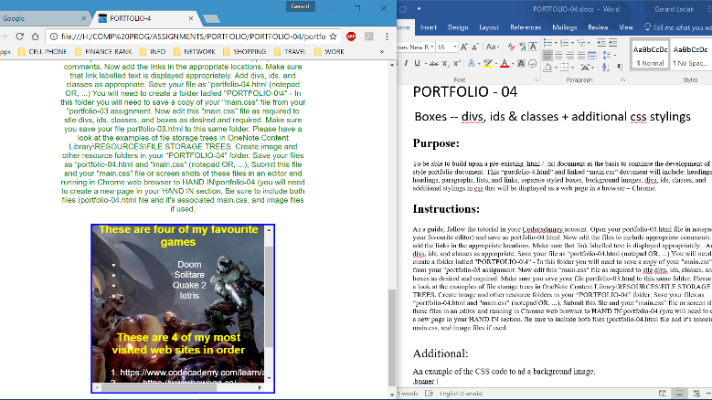 background-image: url("https://s3.amazonaws.com/codecademy-content/courses/web-101/unit-6/htmlcss1-img_tahoe.jpeg");

background-size: cover;

background-position: bottom center;

height: 700px;

width: 100%;

margin: auto;

}